EEK OF RAYER
W
P
HRISTIAN NITY
C
U
FOR

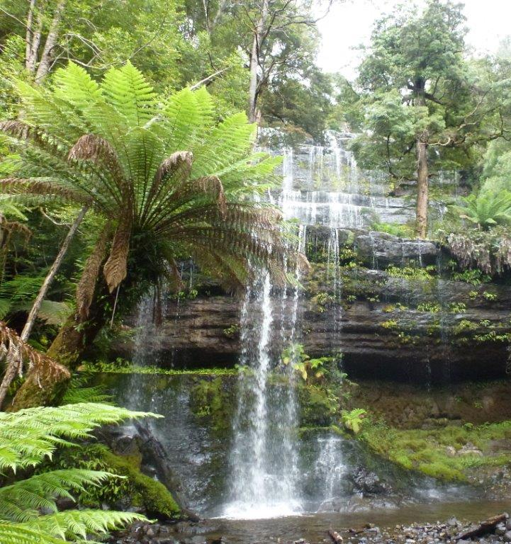

Photo: Russell Falls, Tasmania by Jen Tutin

Jesus said to her; “Give me to drink”.
(John 4:7)



