EEK OF RAYER
W
P
HRISTIAN NITY
C
U
FOR

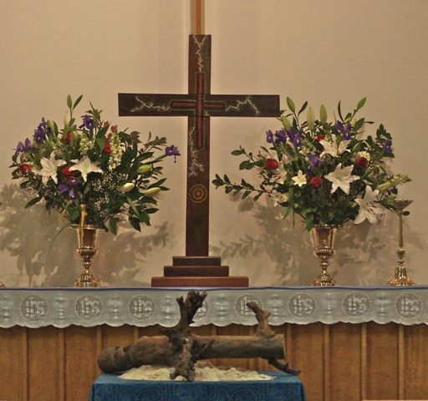

Artist: Raymond Trevaiks Photo: Michael Stephenson

What does God require of us?
(cf Micah 6:6-8)


